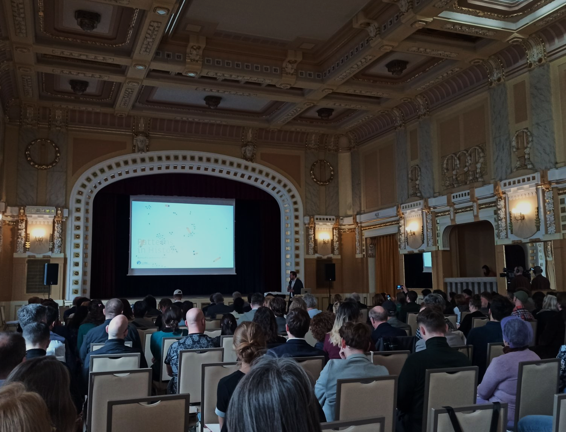

IMPORTANT NOTICE

What is the Application Form?
The Application Form is the template for regranting applications; it must be submitted to EuroClio via email to secretariat@euroclio.eu.

How to prepare and submit it?
The Application Form must be prepared and submitted by a representative via email.
Once submitted, you will receive a confirmation.
Please review the application before submitting to ensure all requirements are met.

Relevant Information:
- Supporting documents can be provided as an annex.
- Please abide by the formatting rules. They are NOT a target! Keep your text as concise as possible. Do not use hyperlinks to show information that is an essential part of your application.

Application
Please read carefully the conditions set out in the Call document/Programme Guide (for open calls: published on the Portal). Pay particular attention to the award criteria; they explain how the application will be evaluated.
Overview of the Application
Type of Grant: | [Cooperation Grant] or [Dissemination Grant]
Name of the Activity:
Date of submission: | DD/MM/YYYY
Coordinator contact: | [Name], [e-mail]
EuroClio Members Involved: | [Name of Member Organisation]

TABLE OF CONTENTS
IMPORTANT NOTICE 2
Application 3
Summary of the Activity 4
Motivation to apply 5
Background and Objectives of the Activity 6
Proposed Programme 8
Budget 9
Tentative outline for the deliverable 10
Tentative plan for the dissemination and communication activities 11

Summary of the Activity
Describe the main objective of the activity, where it will take place, and the members involved in the event. Max. 200 words.

Motivation to apply
Please address all guiding points presented in the Call document. Describe how your organisation will benefit from the activity, what you intend to achieve, and how it fits within your future plans. Max. 1 page.

Background and Objectives of the Activity

Please fill in the corresponding section depending on the type of Grant you are applying for.

For Cooperation Grants
Please address all guiding points presented in the Call document. Please answer the following question: What is the goal of the activity? Which other member organisations will be involved in? Who will be the contributors? How many countries and participants will be present? Where will the activity take place?. Max. 1 page.

For Dissemination Grants
Please address all guiding points presented in the Call document. Please answer the following question: What is the goal of the activity? Who is the target audience of the training? Which EuroClio materials will be used? How many participants will be present? Which other member organisations will be involved? Where will the activity take place? Max. 1 page.

Proposed Programme
Please add a draft of the programme. If there is no definitive programme yet, you can offer a general idea of the different sessions, speakers and length of the event. Max. 1 page.

Budget
Please provide an overview of how the budget will be used by breaking down the event costs (i.e. human resources, travel and stay, subcontracting,...).

Tentative outline for the deliverable
Please provide an outline of the deliverable linked to your activity. For Cooperation Grants, this should be the outline for the in-depth article as mentioned on the call. For Dissemination Grants, this should be the outline of the locally adapted educational resource.

Tentative plan for the outreach and communication activities
Please provide an overview of the expected plan for the outreach and communication of the activities. For Cooperation Grants, this would be how you envision reaching your audience and recruiting your participants, the live reporting of the activities and the further communication on the deliverables. For Dissemination Grants, this would be how you envision sharing your deliverables with your local or regional networks.

