PRESS RELEASE
Revisiting the Common Past: Shared Experiences in Central Europe –
EUROCLIO launches an Educational Website on 20th Century Every Day Life in Central Europe
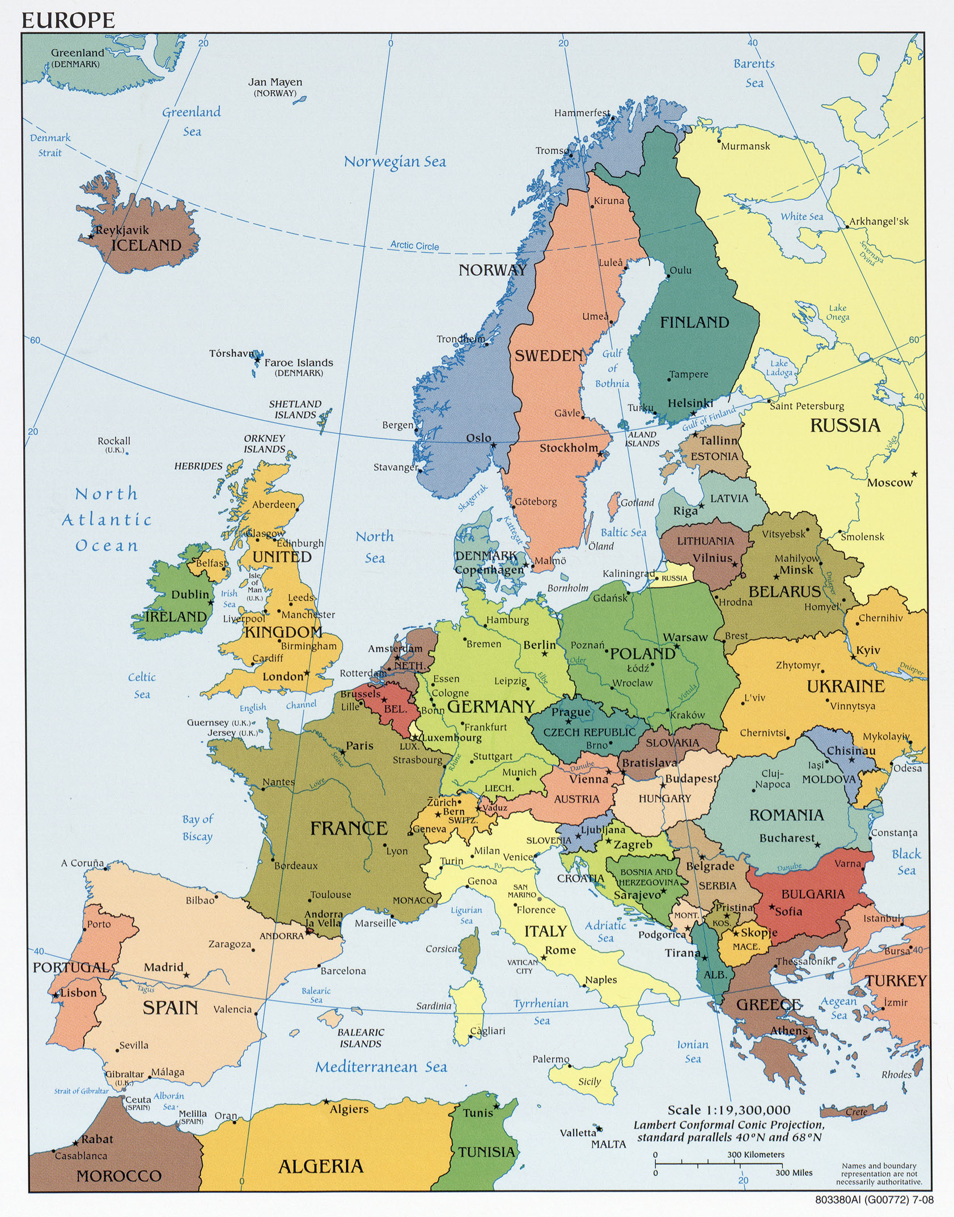
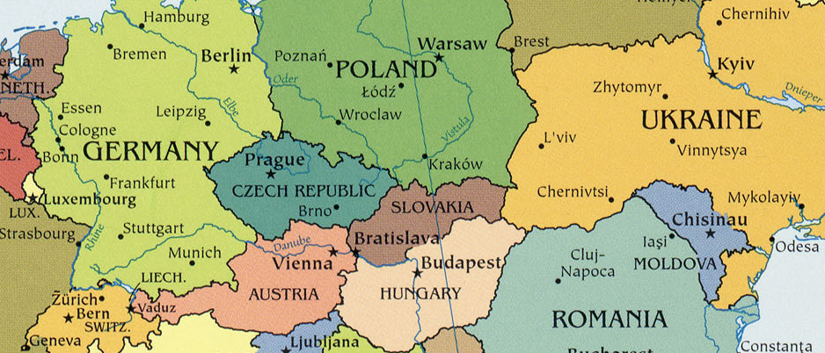
The history of Central Europe in the 20th century is marked by world wars, occupations, forced migration and transfers. Many history books of the region convey the impression that these events happened exclusively in their respective country. In an effort to challenge this nationally-centered approach, history educators from Poland, Germany, Ukraine, Czech Republic, Slovakia, and Hungary worked collaboratively to develop resources for teachers and students who want to study societies and people’s life in these countries after 1945 using a comparative and multiperspective approach.

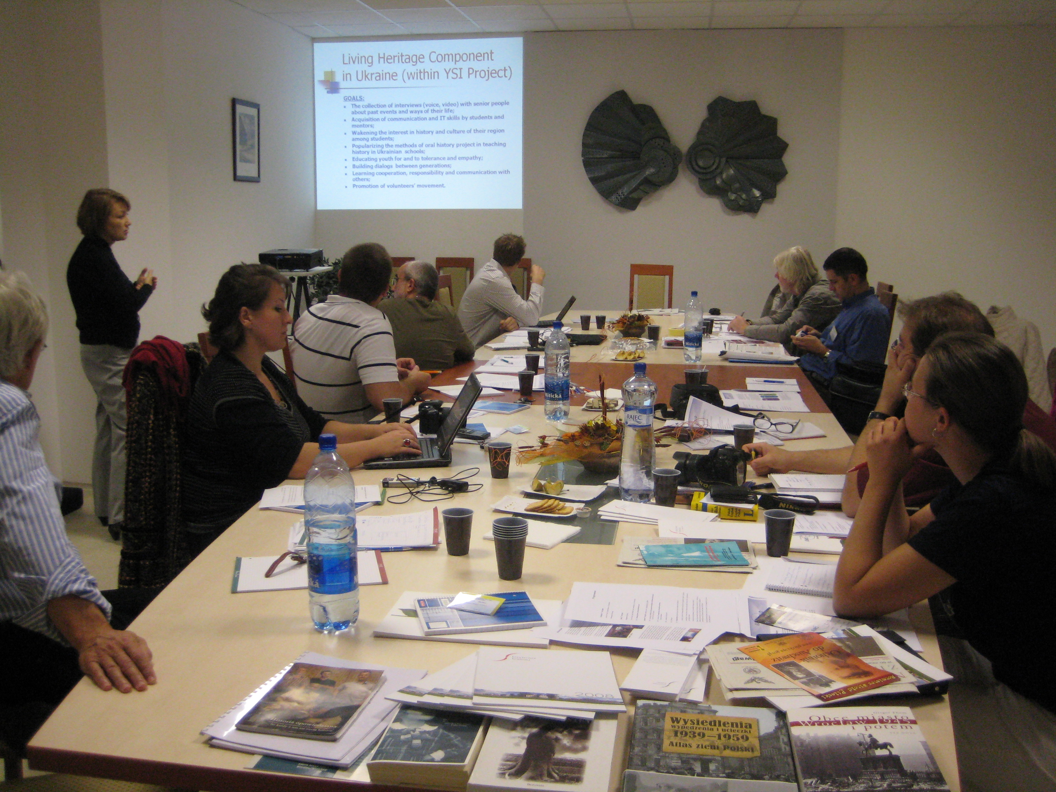
A website is the main result of this unique cooperation which was made possible thanks to the project Connecting Central Europe through Local History, run by EUROCLIO, the European Association of History Educators and funded by the International Visegrad Fund.
School Celebrations, Pioneers Movements, Public Monuments are examples of the topics addressed. The project team created methodological guidelines and teaching ideas on the topics and also actively involved their students in the collection of historical sources and the conduction of interviews among the local populations of their respective countries. Their work resulted in quality educational materials which uncover the connections of local and regional history and convey in the most effective and attractive way the significance of everyday life stories in understanding the history of Central Europe.
For direct contact with the project team, please contact the project manager Eleni Kanava by e-mail at eleni@euroclio.nl or by phone at +31 70 3817836 (EUROCLIO Secretariat office)
http://www.forumhistoriae.sk/euroclio/index.html

